# Title: On all pages. When scrolling down the page, a “Go up” button appears on the left side of the page.

**Priority:** Medium

**Severity:** S5 Trivial

**Environment:**Browser Mozilla Firefox 118.0.1 (64-bit)

Browser Chromium 117.0.5938.132

**Steps to reproduce**

1. Open the Main page: <https://oxford-med.com.ua/ua/>

2. Scroll down the page till the “Go up” button appears.

**Actual result**

The button appeared on the left side:

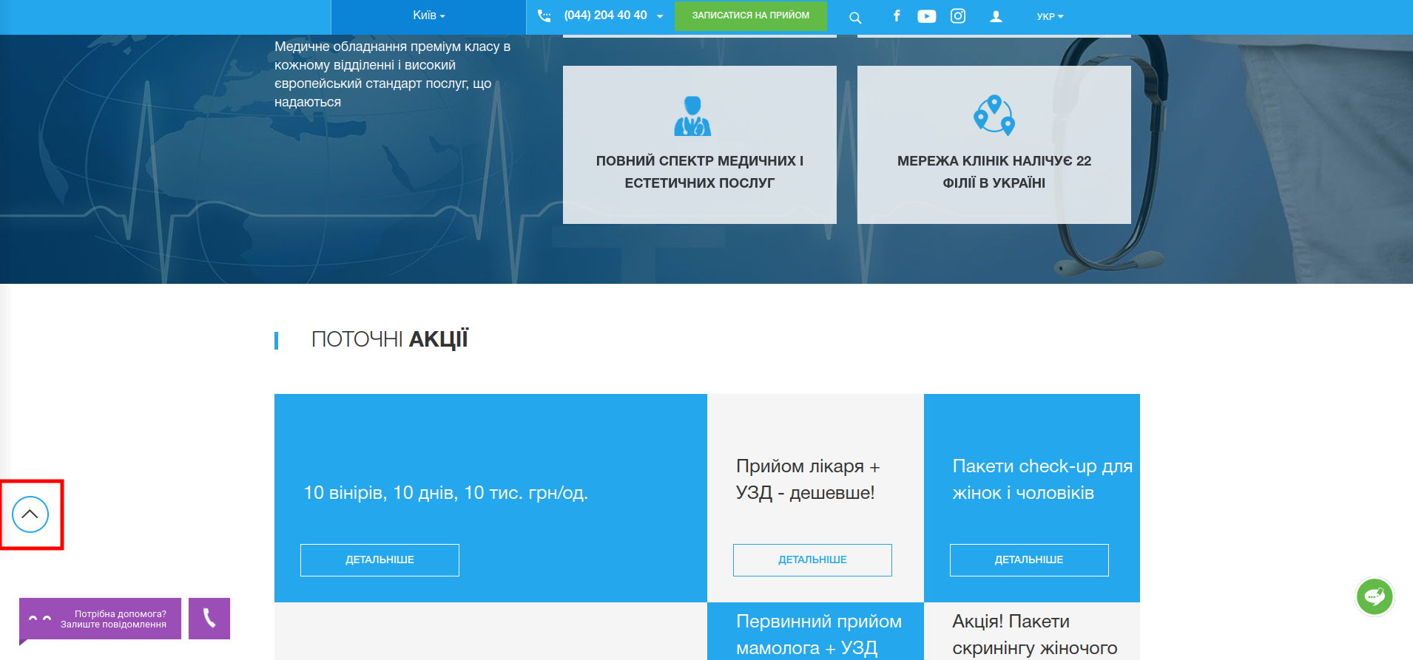

**Expected result**

According to UI-UX, usually “Go up” button appears from the right side of the page (in the USA/EU/CIS region)

*Screenshot from* ***Jira****:*

